CHEMICAL BONDS

A chemical bond is defined as a strong attractive force that exists between two or more atoms to hold them together as a stable molecule in a substance.

Some definitions to understand chemical bonding:
Valence electron: The electrons in the outer most energy level in an atom that takes part in chemical bonding are called valence electrons.
Bonding electrons: The valence electrons actually involved in bond formation are called bonding electrons.
Octet rule: In chemical bond formation, atoms interact- (i) by losing, (ii) by gaining or (iii) by sharing electrons to acquire a stable noble gas configuration. The tendency for atoms to have eight electrons in the outer shell is known as Octet rule.

Main types of bond:
- Ionic or electrovalent bond, (2) Covalent bond, (3) Coordinate covalent bond

Other important bonds:
- Metallic bond, (2) Hydrogen bond

IONIC BOND
An ionic bond is a chemical bond formed by the electrostatic attraction between positive and negative ions. The bond forms between two atoms when one or more electrons are transferred from the valence shell of one atom to the valence shell of the other. The atom that loses electrons becomes a cation (positive ion), and the atom that gains electrons becomes an anion (negative ion).
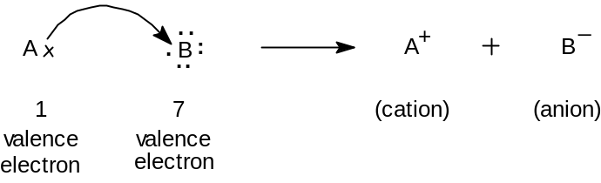

Conditions for formation of ionic bond:
- Bond formations occur between the metal and nonmetal. Metal is donor and nonmetal is acceptor.
- Net lowering of energy:
To form a stable ionic compound, there must be a net lowering of the energy. For example- formation of NaCl molecule
(a) Na ― e → Na⁺ ―119 kcal (energy requires)
(b) Cl + e → Cl‾ +85 kcal (energy releases)
(c) Na⁺ + Cl‾→ Na⁺ Cl‾ +187 kcal (energy releases)
Net energy releases, 187 + 85 ― 119 = 153 kcal
This causes lowering of energy of the process, hence ionic bond formed.
- Electro negativity difference between the atoms
Na → 0.9
Cl → 3.0 Difference, 3.0 ― 0.9 = 2.1
Hence ionic bond will form.
Factors that govern the formation of ionic bond:
- Ionization energy,
- Electron affinity,
- Lattice energy (The energy of an ionic solid is a measure of strength of bonds)

Some examples of ionic bond:
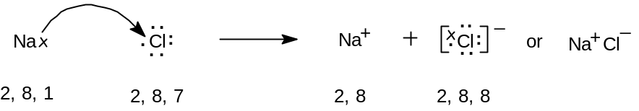
NaCl

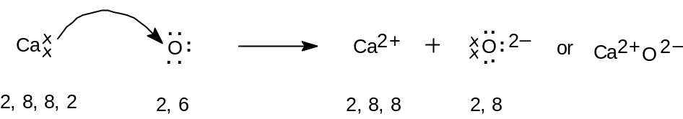
CaO

Characteristics of ionic compounds:
- solids at room temperature
- high melting and boiling points
- hard and brittle,
- soluble in water but insoluble in organic solvents,
- conductors of electricity,
- don’t exhibit isomerism
- undergo ionic reactions which are fast.

COVALENT BOND
The attractive force between atoms created by sharing of an electron-pair.
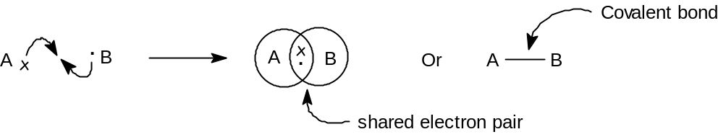

Conditions for formation of covalent bond:
- Bond formations occur between two same or different nonmetals.
- Equal electronegativity
- Equal sharing of electrons

Some examples of covalent compounds:

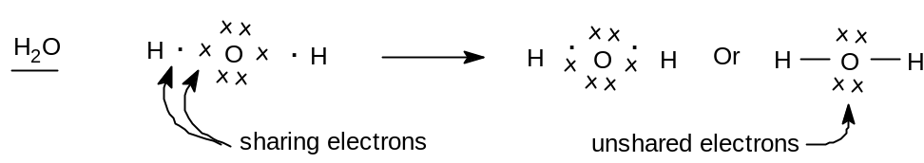

Examples of multiple covalent bonds:
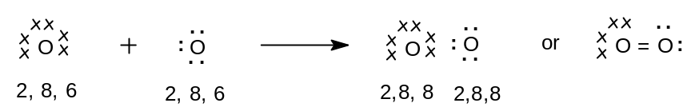
O₂

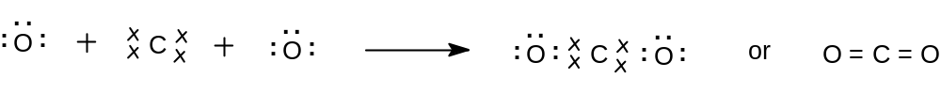
CO₂

Characteristics of covalent compounds:
- Gases, liquids or solids at room temperature,
- Low melting points and boiling points,
- Soft, much readily broken,
- Insoluble in water but soluble in organic solvents,
- Non-conductors of electricity,
- Exhibit isomerism,
- Undergo molecular reactions which are generally slow

COORDINATE COVALENT BOND

A covalent bond in which both electrons of the shared pair come from one of the two atoms (or ions).
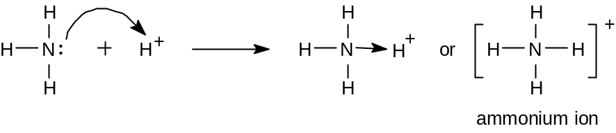
Examples:

NH₄

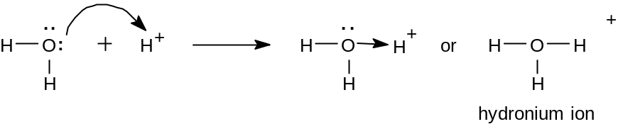
H₃O⁺

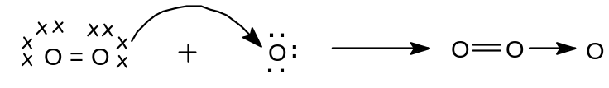
O₃

METALLIC BONDING

The type of bonding which holds the atoms together in metal crystal. A metallic bonding is the electrostatic force of attraction.
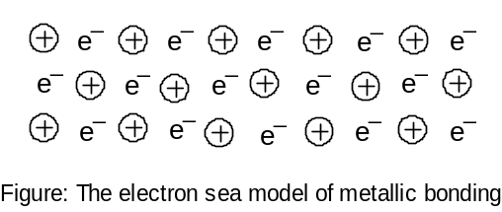

Electric conductivity: It is attended by displacement of electron as a result of voltage at both ends. The mobile electrons are responsible for electric conductivity.
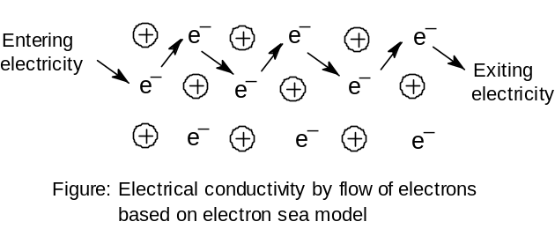

Heat conductivity: It is done by absorbing heat energy and increasing vibrational motion of electron which collide with adjacent electron and transfer energy.
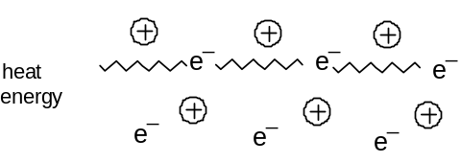

Ductility (that can be made into thin wire) and Malleability (can be pressed into different shapes without breaking): The phenomenon of restoring crystal lattice of metal after applying force, for example by hammering. The sea of electrons adjust position rapidly and the internal structure remains unchanged.
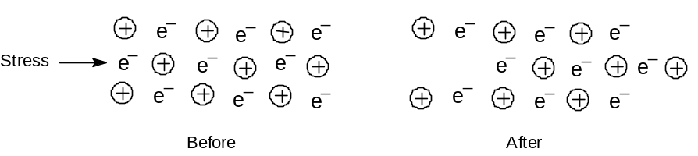

HYDROGEN BOND

- When hydrogen (H) is covalently bonded to a highly electronegative atoms (X= O, F, Cl), the shared electron pair is pulled so close to X that a strong dipole results.
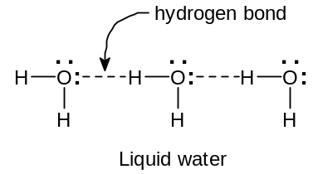
- X ^{δ-} :─ H ^{δ+}

BOND LENGTH, BOND ANGLE AND BOND ENERGY

The distance between the centers of two nuclei of atoms connected by a chemical bond is known as ‘bond length’. It depends on number of bonds. When number of bonds increases, bond length decreases due to more attraction.

The angle between the directions of two bonds in a molecule is called the ‘bond angle’. Bond angle depend upon factors, (i) charge distribution, (ii) geometry of the molecules, (iii) symmetry, (iv) hybridization etc.

Bond energy is defined as the energy required to split the molecule into atoms. It depends on types of bonding- single, double or triple bonds.

